Session 2022-23
TOPPERS OF CLASS X

Session 2021-22
TOPPERS OF CLASS X

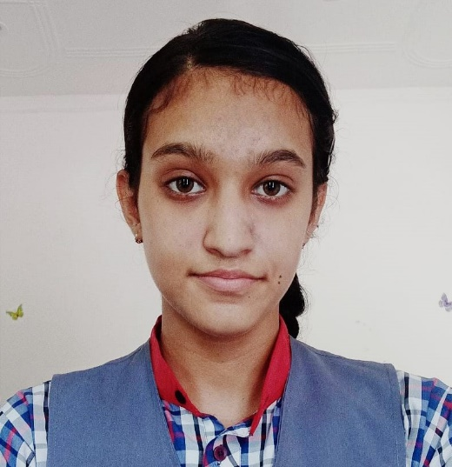VIDUSHI THAKUR | 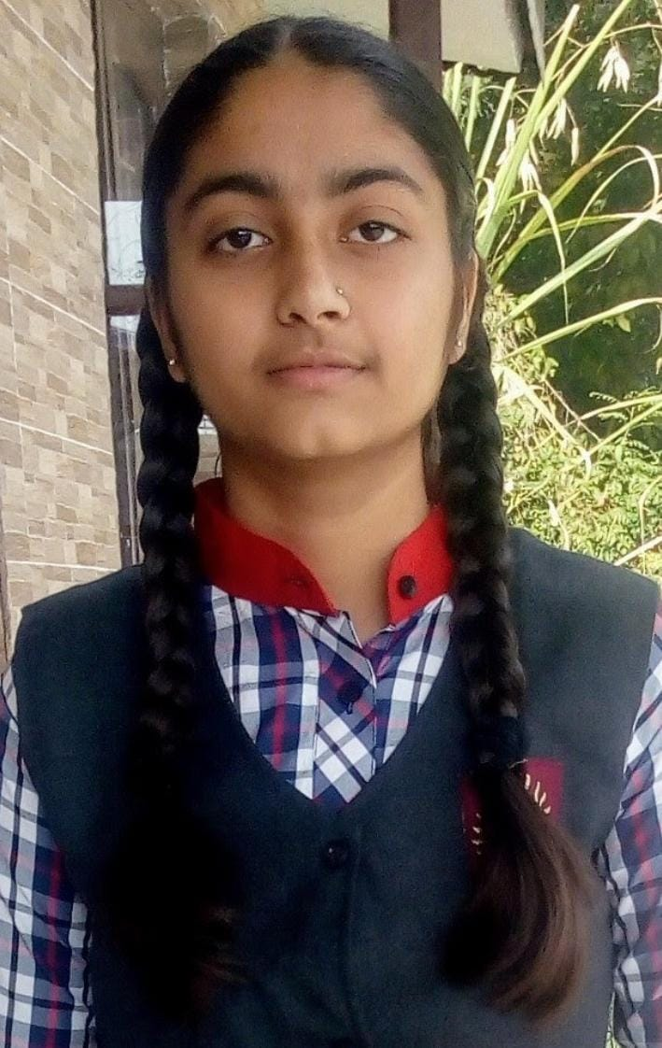  VAISHNAVI SHARMA | 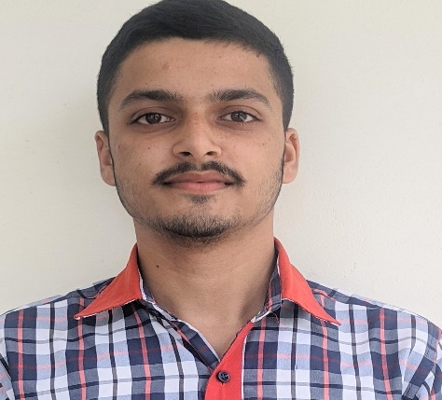  SUMIT
474/500 | 472/500 | 456/500
94.8% | 94.4% | 91.2%

TOPPERS/ Pass Outs who secured 90% or 10 CGPA in (AISSE board exam
CLASS – X
.No. | Name | Marks Secured / CGPA | % of Marks | Rank in KV | Rank in KVS, if awarded cash prize
2020-21
1. | ULLASITA | 474 | 94.8 % | - | 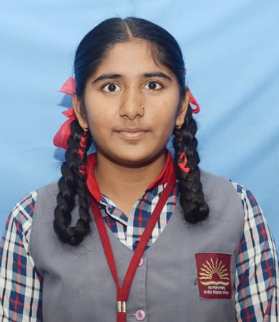
2. | DHRUV SHARMA | 472 | 94.4 % | - | 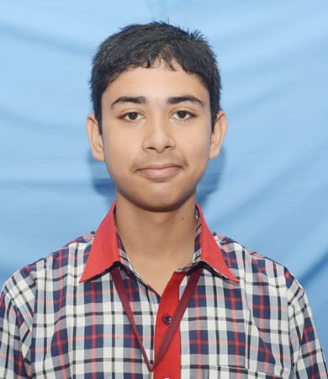
3. | AIKAGRA GUPTA | 470 | 94 % | - | 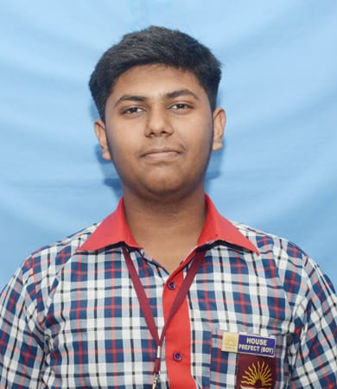

S.No. | Name | Marks Secured / CGPA | % of Marks | Rank in KV | Rank in KVS, if awarded cash prize
2019-20
1. | VANSH DHIMAN | - | 94.8 % | - | 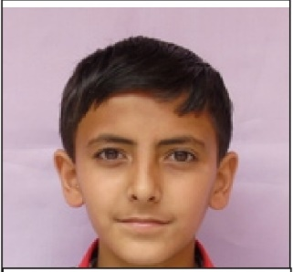
2. | RUDRANSH SHARMA | - | 93 % | - | 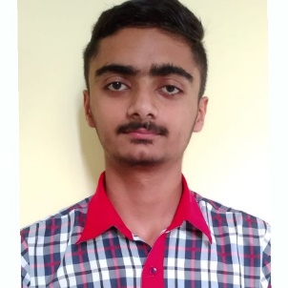
3. | MANSVI SHARMA | - | 91.2 % | - | 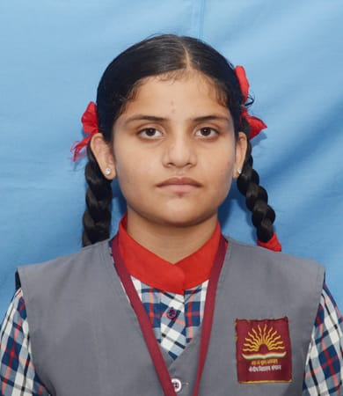
 |  | 2016-17
1. | Master Shubham Sharma | 10 | - | - | -
2. | Kumari Anuradha Singh | 10 | - | - | -
3. | Kumari Palak Thakur(2014-15) | 9.6 | - | - | -
4. | Kumari Saksham Thakur(2014-15) | 9.4 | - | - | -
5. | Sahil Jaswal(2014-15) | 9.0 | - | - | -
6. | Hitakshi Prasher(2015-16) | 10.0 | - | - | -
7. | Ritika Rajput(2015-16) | 10.0 | - | - | -
8. | Shifali(2015-16) | 10.0 | - | - | -
9. | Akshita (2016-17) | 10.0 | - | - | -
10. | Anshika Garg (2016-17) | 10.0 | - | - | -
11. | Ashima Dhiman (2016-17) | 10.0 | - | - | -
12. | Rhythm (2016-17) | 10.0 | - | - | -
13. | Vaishnavi (2016-17) | 10.0 | - | - | -
14. | Akshita (2016-17) | 10.0 | - | - | -
2017-18
15. | Anjali F | - | 92.4 % | - | -
16. | Kritika Sharma | - | 91.6 % | - | -
17. | Anchal F | - | 91.4 % | - | -
2018-19
18. | P S L KATYAYANI | - | 94.8 % | - | -
19. | MANSHI SHARMA | - | 94.4 % | - | -
20. | AKSHITA GARG | - | 94 % | - | -

